Practice & Past MCQ Quiz Questions: | Answer | Explanation
Sally (an Australian resident) operates her own business as a lawyer. She receives the following amounts/benefits in the year ended 30 June 2021. Sally recognises for income on an accruals basis for taxation purposes.  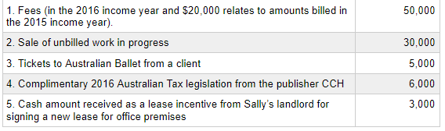  What is Sally’s assessable income for the year ended 30 June 2021? Ignoring GST, choose the correct response the following:  A.$94,000.  B.$68,000.  C.$63,000.  D.$85,000. | C | - The correct answer is $63,000 ($30,000 (fees) + $30,000 + $3,000).  - As Sally accounts for income on an accruals basis, only the current year billed amount totalling $30,000 is assessable under s. 6-5 ITAA1997  - Sale of work in progress is assessable under s. 15-50 ITAA 1997. The tickets are excluded under s. 21A(4) ITAA 1936 because they are entertainment. The tax legislation is excluded under s. 21A(3) ITAA 1936 because it is otherwise deductible. As the lease incentive is received as a cash amount it is assessable under s. 6-5 ITAA 1997.
Knife Pty Ltd (Knife) is an Australian resident company. Knife has the following liabilities on its balance sheet for accounting purposes as at 30 June 2021. All amounts have been expensed in its accounting profit for the year ended 30 June 2021 (i.e. the opening balance of the liability accounts is nil (zero)).  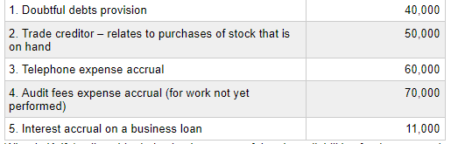  What is Knife’s allowable deduction in respect of the above liabilities for the year ended 30 June 2021? Ignoring GST, choose the correct response from the following:  A.$121,000.  B.$191,000.  C.$71,000.  D.$110,000. | A | - The correct answer is $121,000 ($50,000 + $60,000 + $11,000).  - The stock purchases, telephone and interest expenses represent presently existing pecuniary obligations and are therefore deductible under s. 8-1 ITAA 1997.  - The doubtful debts provision and the accrued audit fees reflect uncommitted or future obligations and are therefore not yet incurred under s. 8-1 ITAA 1997.
Stove Pty Ltd (Stove), is an Australian resident company. Stove has the following expenses in its accounting profit for the year ended 30 June 2021. (Note: Stove is not a small business entity (SBE) taxpayer / ignore the SBE rules covered later in the learning materials).  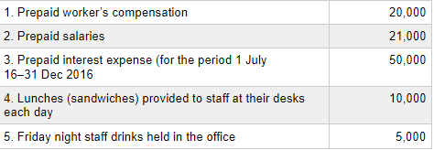  What is Stove’s allowable deduction for the year ended 30 June 2021? Ignoring GST, choose the correct response from the following:  A.$51,000.  B.$91,000.  C.$56,000.  D.$101,000 | A | - The correct answer is $51,000 ($20,000 + $21,000 + $10,000).  - The prepaid worker’s compensation and salaries are excluded expenditure and are therefore not subject to the prepayment provisions (s.82KZL ITAA 1936).  - The prepaid interest expense is not deductible under s. 82KZMA ITAA 1936 as the eligible service period relates to a period after 30 June 2021.  - As the staff lunches are sustenance, the expenditure is not non-deductible entertainment under s. 32-5 ITAA 1997.  - The staff drinks are non-deductible entertainment under s. 32-5. As food and drink provided to staff on a working day on employer premises is exempt from FBT under s. 41 FBTAA 1986, s. 32-20 does not provide a tax deduction for this expenditure.
Diamond Pty Ltd (Diamond), an Australian resident company, provides you with the following taxation information in relation to its sales and trading stock for the income year ended 30 June 2021 income year:  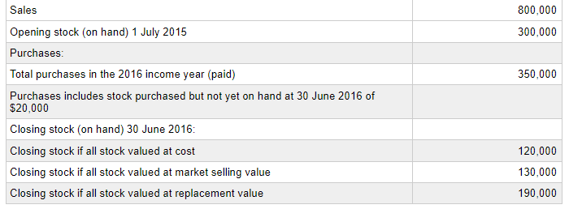  Assume that Diamond is not a small business entity (SBE) taxpayer / ignore the SBE rules covered later in your learning materials.  Ignoring GST, what is Diamond's minimum taxable income for the income year ended 30 June 2021? Choose the correct response from the following:  A.$270,000  B.$360,000  C.$340,000  D.$290,000 | D | The minimum taxable income for the income year is calculated as:  - Sales income +$800k; less  - Purchases -$350k  - Adjust for stock not yet on hand +20k  - Movement in stock values s70.35(3) [$120k - $300k] = -$180k  - Net = Taxable income = $290k  Explanation of the -$180k:  - In order to minimise taxable income, it should maximise its s. 70-35(3) deduction.  - This means that the closing stock value should be as low as possible  - Market value is the valuation method that will provide the highest deduction as is results in the lowest closing stock.  Explanation of the +$20k:  Purchases of stock are deductible only when on hand: s. 70-15 ITAA 1997
Spanner Pty Ltd (Spanner) is an Australian resident food distribution company. Spanner pays the following GST-inclusive amounts (where applicable) related to its GST-registered Australian business:  Payments  1. Employee bonus paid as wages  2. Rent on commercial property  3. Parking fines for its delivery drivers  4. Acquisition of new office computers  5. Import of breakfast cereal products from New Zealand  What is Spanner’s ITC entitlement in respect of the above payments? Choose the correct response from the following:  A.$7,272.  B.$9,090.  C.$10,909.  D.$17,272 | A | - The correct answer is $7,272 [($50,000 + 30,000) × 1/11].  - The rent on the commercial property and the acquisition of the office computers are creditable acquisitions which give rise to an ITC (s.11-15 GST Act). All the other acquisitions are not creditable acquisitions.  - The supply of services by an employee is not a taxable supply as wages are excluded from the definition of an enterprise (s.9-20(2)(a) GST Act).  - An ITC is not available in relation to non-deductible fines (Division 69 GST Act).  - An ITC does not arise for the import of breakfast cereals. It is a non-taxable importation as it would have been a GST-free supply if the supply had been made in Australia(s.15-5).
Ant Pty Ltd (Ant) is an Australian resident company that carries on business as a health insurance business. It receives the following GST-inclusive amounts (where applicable) related to its GST-registered Australian business:  Receipts  1. Health insurance premiums  2. Rent on residential property  3. Dividend income  4. Repayment of loan from a subsidiary company  5. Sale of a business (as a going concern)  What is Ant's minimum amount GST in respect of the above receipts?  Choose the correct response from the following:  A.$5,454.  B.$10,909.  C.$0.  D.$17,273. | C | - The correct answer is $0.  - No GST liability arises as none of the items are taxable supplies.  - Health insurance premiums are GST-free supplies (Subdivision 38-B GST Act).  - Residential rent, dividend income and the repayment of the loan are input taxed supplies upon which no GST liability arises (Division 40 GST Act).  - Where a business is sold as a going concern it is GST-free where the supplier and recipient have agreed. Agreeing to this would minimise Ant's GST liability (Subdivision 38-5 GST Act).
Sinker Pty Ltd (Sinker) is an Australian resident company. Sinker pays and receives the following GST-inclusive amounts (where applicable) related to its GST-registered Australian business:  Amounts received  1. Fees from the provision of child care services  2. Sale of shares  Amounts paid  3. Wages  4. Acquisition of shares  5. Fines  What is Sinker's net GST payable/refundable in respect of the above transactions? Choose the correct response from the following:  A. $0 payable.  B. $4,182 payable.  C. $4,545 payable.  D. $545 refundable . | A | - The correct answer is nil.  - There are no taxable supplies or creditable acquisitions. Fees from the provision of child care services are GST free (Subdivision 38-D GST Act).  - The sale of shares is a financial supply which is input taxed (s. 40-5 GST Act).  - An ITC does not arise for wages. The supply of services by an employee is not a taxable supply as wages are excluded from the definition of an enterprise (s. 9-20 (2)(a) GST Act).  - An ITC is not available for the fine as it is non-deductible expenditure (Division 69 GST Act).  - An acquisition of shares relates to the making of input taxed supplies (i.e. not a creditable acquisition s. 11-15 GST Act).
Binder Pty Ltd (Binder) is an Australian resident company. Binder provides the following external benefits during the current FBT year to its employees. All amounts are GST-inclusive where applicable.  Benefit  1. Light sandwiches in the park each day for employees  2. Television sets for employees at their homes ($3,000 each)  3. Gift voucher for managing director  4. Friday night drinks in the office for spouses of employees ($500 per head)  5. Forgiveness of loan to employee  What is the taxable value of the fringe benefits provided (before the gross-up) for the year ended 31 March 2021, assuming that Binder does not make any elections? Choose the correct response from the following (All amounts are GST-inclusive where applicable):  A.$99,000.  B.$119,000.  C.$117,000.  D.$107,000. | B | - The correct answer is $119,000 the total of all the benefits.  - The light sandwiches offsite, the television sets, the gift voucher and the Friday night drinks are property benefits under s. 40 FBTAA 1986 (note that the s. 41 FBTAA 1986 exemption does not apply to associates).  - The loan forgiveness is a debt waiver fringe benefit under s. 14 FBTAA 1986.
Rubber Pty Ltd is an Australian resident company. Rubber provides the following external benefits during the current FBT year.  Benefit  1. On 1 April 2021 an interest-free loan was provided to employee’s wife (used to buy rental property)  2. Reimbursement of tax return fees to an employee  3. Value of car transferred as part of a salary-sacrificed bonus to an employee  4. Home-to-work taxi travel for employees  5. Reimbursement of repair costs on a company-owned car provided to employee  A.$0.  B.$150,000.  C.$40,000.  D.$90,000 | C | - The correct answer is $40,000 (i.e. $10,000 + $30,000).  - The otherwise deductible rule does not apply to loans to spouses. The taxable value of the loan fringe benefits = $177,000 × statutory interest rate 5.56% = $10,000.  - The otherwise deductible rule applies to the tax return fees.  - The car is a property fringe benefit.  - The home-to-work taxi travel is exempt under s. 58Z FBTAA 1986.  - The repairs are exempt under s. 53 FBTAA 1986 as they are provided in relation to a company owned car.
Lace Pty Ltd (Lace) is an Australian resident company. Lace provides the following payments to a retiring employee:  Payments  1. Unused rostered days off  2. Annual leave  3. ‘Golden handshake’ retirement payment  4. Gratuity for good service  5. Unused sick leave  What is the employee's eligible termination payment? Choose the correct response from the following:  A.$80,000.  B.$0.  C.$160,000.  D.$140,000. | D | - The correct answer is $140,000 (i.e. $10,000 + $30,000 + $40,000 + $60,000).  - The annual leave is excluded from the definition of employment termination payment (s. 82-135 ITAA 1997).
Bulimba Pty Ltd (Bullimba), an Australian resident company, is a wholesaler of Widget spinners. Bulimba provides you with the following taxation information in relation to its sales and trading stock for the income year ended 30 June 2021:  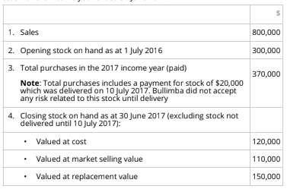  Ignore GST and the same business entity rules (covered later in your learning materials). What is Bulimba’s minimum taxable income for the income year ended 30 June 2021? Choose the correct response from the following:  - $240,000  - $260,000  - $280,000  - $300,000 | B | The minimum taxable income for the income year is calculated as:  - Sales income +$800k; less  - Purchases -$370k  - Adjust for stock not yet on hand +20k  - Movement in stock values s70.35(3) [$110k - $300k] = -$190k  - Net = Taxable income = $260k  Explanation of the -$190k:  - In order to minimise taxable income, it should maximise its s. 70-35(3) deduction.  - This means that the closing stock value should be as low as possible  - Market value is the valuation method that will provide the highest deduction as is results in the lowest closing stock.  Explanation of the +$20k:  - Purchases of stock are deductible only when on hand: s. 70-15 ITAA 1997
Bogut Pty Ltd (Bogut) is an Australian resident company that operates a manufacturing business. Bogut pays its suppliers the following GST-inclusive amounts (where applicable) related to its GST- registered Australian business:  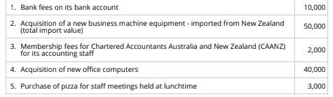  What is Bogut’s ITC entitlement in respect of the above payments? Choose the correct response from the following:  - $6,091.  - $9,727.  - $9,091.  - $9,545. | C | - The correct answer is $9,091 ($5,000 + $182 + $3,636 + $273)  - Bank fees are financial supplies, no ITC available (s.40-5.09)  - Imported machinery, the importer pays GST but also gets an ITC if a creditable importation (YES as would not be gST free in AUS) = $5,000 ($50,000/10 as price is not GST inclusive)  - CA fees relate to memberships (not an education course) so aren’t exempt under ss.38-C therefore an ITC applies ($2,000/11) = $182  - Acquisition of the office computers are creditable acquisitions which give rise to a $3,636 ITC (s.11-15 GST Act) [$40,000/11]  - Purchase of pizza is creditable acquisition Note can only claim meal entertainment if subject to FBT = $273 ITC [$3000/11)
Nifty Gifty Pty Ltd (NG) is an Australian resident company that carries on business. NG receives the following GST-inclusive amounts (where applicable) related to its GST-registered Australian business:  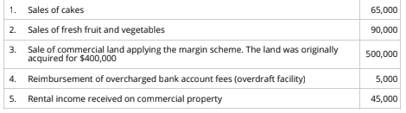  What is NG’s minimum GST liability in respect of the above receipts? Choose the correct response from the following:  - $19,545.  - $19,091.  - $27,273.  - $60,000. | B | - The correct answer is $19,091 ($5,909 + $9,091 + $4,091)  - Sale of cake is a taxable supply (GST = $65,000 / 11 = $5,909)  - Sale of fresh fruit are GST-free supplies (Subdivision 38-B GST Act).  - Margin scheme = 1/11th of (SALE PRICE - COST OF ACQUISITION) = ($500k-400k)/11 = $9091  - Bank account fees are a financial supply and therefore input taxed = 0 (s.40-5.09)  - Commercial rent is a taxable supply (GST = $45,000 /11 = $4,091) Note: residential rent is input taxed supply though.
What is Crown’s minimum net GST payable/refundable in respect of the above transactions?  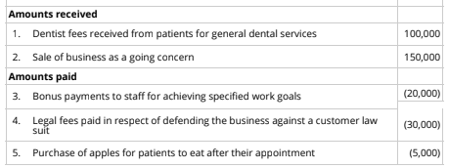  Choose the correct response from the following:  - $17,727 payable.  - $2,727 refundable.  - $6,364 payable.  - $20,000 payable. | B | - The correct answer is $2,727 (legal fees)  - Dentist fees are GST Free (health exemption ss.38-B) - nil  - Sale of going concern is GST free ss.38-J (s38-225(1)) Note: ensure it actually meets definition of going concern. – nil  - Bonus is wages. An ITC does not arise for wages. The supply of services by an employee is not a taxable supply as wages are excluded from the definition of an enterprise (s. 9-20 (2)(a) GST Act).  - Legal fees are a taxable supply - $2,727 ITC arises (refundable) [=$30k / 11)  - Sale of fresh fruit are GST-free supplies (Subdivision 38-B GST Act). - nil
Cupid Pty Ltd (Cupid) is an Australian resident company. Cupid provides the following external benefits to its employees during the FBT year ended 31 March 2021. All amounts are GST-inclusive (where applicable).  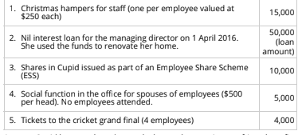  Assume Cupid has not elected to apply the meal entertainment fringe benefit rules. What is taxable value of the fringe benefits provided (before the gross-up) for the FBT year ended 31 March 2021? Choose the correct response from the following:  - $2,400.  - $11,400.  - $36,400.  - $31,400. | B | - The correct answer is $11,400 ($2.4k + $5k + $4k)  - Christmas hampers fall under minor benefits exemption (s58P) = $0  - Loan = fringe benefit. TAXABLE VALUE = 50,000 x (4.80% statutory interest – 0 actual interest) x (365/365) = $2,400  - Benefits under employee share schemes are outside scope of FBT (s136 (1)) = $0  - Social function: Where no election of division 9A, FBT will be based on ACTUAL MEALS (and associated costs) provided to employees. Spouses count as associates of employees, therefore tax. value = $5,000  - Tickets to grand final is a property fringe benefit. No exemptions applicable, therefore taxable value = $4,000
Chitty Pty Ltd (CC) is an Australian resident company and is registered for GST purposes. During the FBT year ended 31 March 2021, CC reimbursed one of its employees $1,200 for the cost of their home internet. The employee used the internet solely for private purposes. What is the FBT payable, GST ITC (ITC) available and the income tax deduction (ignoring the deduction for FBT payments where relevant) for CC in relation to the reimbursement? Choose the correct response from the following:  - 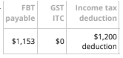  - 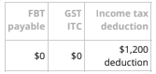  - 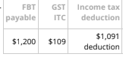 | C | - The cost of the home internet provided would give rise to a fringe benefit. The taxable value is NOT reduced to by the otherwise deductible rule as it was used for private purposes.  - The FBT taxable value for the internet is equal to its cost of $1,200  - As the internet is a creditable acquisition, it gives rise to an input tax credit totalling $109 ($1,200/11).  - Since FBT applies the GST exclusive-cost totalling $1,091 (i.e. $1,200 × 10/11) is deductible under s. 8-1 (employee remuneration expenses incurred in carrying on a business)
Tony worked for Avenga Pty Ltd (Avenga) an Australian resident company. After 6 complete years of service his position was made redundant on 30 June 2021. Tony is aged 48 years. At the time of his redundancy, Tony received the following payments.  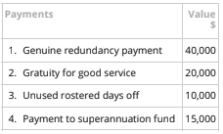  What is Tony’s employment termination payment for income tax purposes? Choose the correct response from the following:  - $85,000.  - $30,250.  - $60,000.  - $30,000. | B
Sally, a lawyer, who carries on her own business receives the following amounts/benefits in the year ended 30 June 2021:  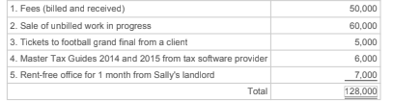  What is Sally's assessable income for the year ended 30 June 2021? Ignoring GST, choose the correct response from the following:  A. $110,000.  B. $115,000.  C. $128,000.  D. $121,000. | A | - The correct answer is $110k ($50k + $60k).  - As Sally accounts for income on an accruals basis, only the current year billed amount totalling $50k is assessable under s. 6-5 ITAA1997  - Sale of work in progress is assessable under s. 15-50 ITAA 1997. - $60k  - The tickets are excluded under s. 21A(4) ITAA 1936 because they are entertainment.  - The tax legislation is excluded under s. 21A(3) ITAA 1936 because it is otherwise deductible.  - Non-cash benefit s21A which would be assessable if could be converted to cash but otherwise deductible applies = not assessable. NIL.
Plate Pty Ltd (Plate) an Australian resident company has the following liabilities on its balance sheet as at 30 June 2021:  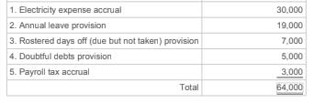  What is Plate's allowable deduction in respect of the liabilities for the year ended 30 June 2021? Ignoring GST, choose the correct  response from the following:  A. $40,000.  B. $49,000.  C. $33,000.  D. $30,000. | C | - The correct answer is $33k ($30k + $3k).  - 1. The electricity accrual represent presently existing pecuniary obligations and are therefore deductible under s. 8-1 ITAA 1997. – $30k  - 2 & 3. Annual leave & rostered days are deductible when paid & THEREFORE not deductible (s.26-10 and Flood case) - nil  - The doubtful debts provision reflect uncommitted or future obligations and are therefore not yet incurred under s. 8-1 ITAA 1997.  - The payroll tax accrual represent presently existing pecuniary obligations and are therefore deductible under s. 8-1 ITAA 1997. – $3k
Oven Pty Ltd (Oven), an Australian resident company, has the following expenses included in its profit and loss account for the income year ended 30 June 2021. (Note: Oven is not a Small Business Entity taxpayer.)  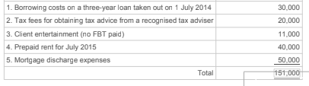  What is Oven's allowable deduction in respect of the expenses for the year ended 30 June 2021? Ignoring GST, choose the correct response from the following:  - $80,000.  - $74,000  - $24,000  - $91,000 | A | - Correct answer = $80k ($10k+$20k+$50k)  - Borrowing costs are deductible over the lesser of the life of the loan or 5 years where borrowing for income producing purposes. Therefore deduction = $10k per year (3 yrs)  - Tax advice fees are deductible (s25-25) $20k  - Entertainment not deductible unless FBT paid – nil  - Prepaid rent not deductible as oven is not SBE and rent for July next year is not yet incurred. – nil  - You can deduct expenditure you incur to discharge a mortgage that you gave as security for the repayment of money you borrowed, if you used the money solely for purposes of producing assessable income (s25-30(1)) - $50k
Door Pty Ltd (Door) an Australian resident company has the following trading stock on hand at 30 June 2021:  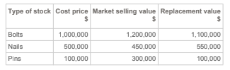  Calculate Door's closing stock value that would minimise Door's assessable income. Choose the correct response from the following:  A. $1,950,000.  B. $2,050,000.  C. $1,550,000.  D. $1,600,000. | C | - In order to minimise taxable income, it should maximise its s. 70-35(3) deduction.  - This means that the closing stock value should be as low as possible  - Simply choose lowest amount for each type of stock  - $1m + $450k + $100k = $1.55m
Hammer Pty Ltd (Hammer) pays the following GST-inclusive amounts where applicable related to its GST-registered Australian business:  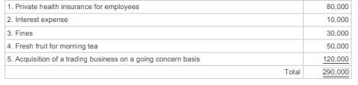  Calculate Hammer's minimum possible ITC. Choose the correct response from the following:  A. $0.  B. $15,455.  C. $26,364.  D. $11,818. | A | - Answer = 0 (see below)  - Health insurance premiums are GST-free supplies (Subdivision 38-B GST Act).  - Interest are a financial supply and therefore input taxed = 0 (s.40-5.09)  - An ITC is not available in relation to non-deductible fines (Division 69 GST Act).  - Sale of fresh fruit are GST-free supplies (Subdivision 38-B GST Act).  - Where a business is sold as a going concern it is GST-free where the supplier and recipient have agreed. Agreeing to this would minimise GST liability (subdiv 38-5).
Ant Pty Ltd (Ant) receives the following GST-inclusive amounts related to its GST-registered Australian business:  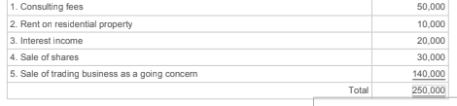  Calculate the minimum amount of Ant's net GST payable to/refundable from the Australian Tax Office. Choose the correct response from the following:  A. $4,545.  B. $17,273.  C. $10,909  D. $12,727 | A | - Answer is $4,545 (Consulting fees only)  - GST will apply to consulting fees as it is a creditable acquisition = $50k/11 = $4,545  - Residential rent input taxed supplies upon which no GST liability arises (Div 40 GST).  - Interest are a financial supply and therefore input taxed = 0 (s.40-5.09)  - The sale of shares is a financial supply which is input taxed (s. 40-5 GST Act).  - Where a business is sold as a going concern it is GST-free where the supplier and recipient have agreed. Agreeing to this would minimise Ant's GST liability (Subdivision 38-5 GST Act).
Line Pty Ltd pays and receives the following GST-inclusive amounts where applicable related to its GST-registered Australian business:  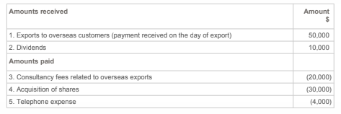  Calculate the net GST amount payable to/receivable from the Australian Tax Office. Choose the correct response from the following:  A. $545 receivable.  B. $4,545 payable.  C. $2,182 receivable.  D. $4,182 payable. | C | - Answer = ($2,182 rec. = $1,818 + $363)  - Exports are GST-Free. Note: has to be exported within 60 days of receiving money for item or issuing invoice to be GST free) (ss.38-E (s.38-115)) = 0  - Dividends are a financial supply and therefore input taxed = 0 (s.40-5.09)  - Exports are GST free meaning supplier can claim ITC on making the GST-free supply. Therefore ITC = $20k/11 = $1,818  - The sale of shares is a financial supply which is input taxed (s. 40-5 GST Act).  - Telephone is creditable acquisition, therefore ITC = $4k/11 = $363
Pad Pty Ltd (Pad) provides the following external benefits to its employees:  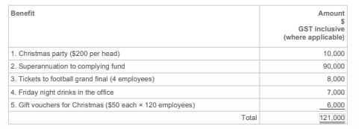  Calculate the taxable value of the fringe benefits provided (before the gross-up), assuming that Pad uses the 50/50 split method under  Division 9A FBTAA 1986 for calculating its meal entertainment fringe benefits. Choose the correct response from the following:  A. $12,500.  B. $16,500.  C. $25,000.  D. $22,500. | B | - The correct answer is $16.5k ($5k + $8k + $3.5k)  - Note: Pad elected 50/50 method which means a) exemption for on business premises and b) minor benefits are foregone for any items under meal entertainment.  - Normally, Xmas party falls under minor benefits exemption (s58P) but 50/50 applies as meal entertainment so = $10k / 2 = $5k  - Super outside scope of FBT (s136 (1)) = $0  - Tickets to grand final is a property fringe benefit. No exemptions applicable = $8k  - Social function: on premises exemption foregone due to 50/50 = $7k /2 = $3.5k  - Gift vouchers are property fringe benefit. S58 still relevant as not ‘meal entertainment’ = $0
Sock Pty Ltd (Sock) provides the following payments to a retiring employee:  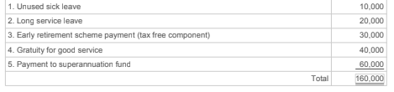  Calculate the employment termination payment. Choose the correct response from the following:  A. $0.  B. $160,000.  C. $70,000.  D. $50,000. | D | - Answer is $50k ($10k + $40k)  - Unused sick leave = $10k  - LSL are excluded from ETP (s82-135) - $0  - Tax free component excluded (s81-140)  - Gratuity – included - $40k  - Payment to superfund – excluded (s82-135) - $0
Jimmy (an Australian resident), operates his own business as a lawyer. Jimmy recognises his income on an accruals basis for income tax purposes. He received the following amounts/benefits in the income year ended 30 June 2021.  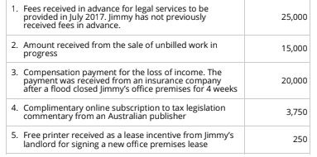  Ignore GST and the small business entity rules (covered later in your learning materials). What is Jimmy’s assessable income in respect of the above items for the income year ended 30 June 2021? Choose the correct response from the following:  - $35,000.  - $15,000  - $18,750  - $15,250 | A | - The correct answer is $35k ($15k + $20k)  - As Jimmy accounts for income on an accruals basis, only the current year billed amount totalling $0 is assessable under s. 6-5  - Sale of work in progress is assessable under s. 15-50 ITAA 1997. = $15k  - Compensation – key question is if its capital or income. Income replacement – assessable (s15-30) = $20k  - The tax legislation is excluded under s. 21A(3) ITAA 1936 because it is otherwise deductible.  - The printer is excluded under s. 21A(3) ITAA 1936 because it is otherwise deductible.

